**To successfully install Oracle 12c two node RAC on Virtual box requires at least 12GB of host operating system memory. Each RAC node must have greater than 4GB of memory and greater than 3 GB or equal size of RAM size for SWAP. Below is my host configuration detail**

CPU: I5-4210U 2.7 GHz 2 Cores

Memory: 16 GB

Host OS: Windows 8.1

Guest OS: Oracle Linux 7

Grid/Database Software version: 12.2.0.2

Virtual Box version: 4.3.26 (if you are using windows 10 then go for version 5)

**Network Configuration**

**DNS Server IPAddress**

dnsnode 192.168.0.40

**Public IpAddress**

node1 192.168.0.101

node2 192.168.0.102

**Virtual IpAddress**

node1-vip 192.168.0.201

node2-vip 192.168.0.202

**Private IpAddress**

node1-priv 192.168.1.101

node2-priv 192.168.1.102

**Scan IpAddress**

racdb-scan 192.168.0.71

racdb-scan 192.168.0.72

racdb-scan 192.168.0.73

Domain: hari.com

**Download Virtual box 4.3.26**

<http://www.oracle.com/technetwork/server-storage/virtualbox/downloads/index.html#vbox>

**Download Oracle Software 12.2.0.2**

<http://www.oracle.com/technetwork/database/enterprise-edition/downloads/index.html>

**Download Linux 7**

<https://edelivery.oracle.com/>

**Install Oracle Virtual box**

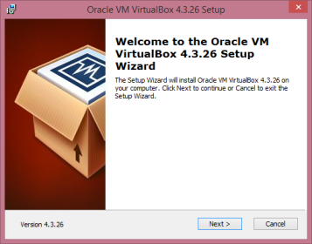

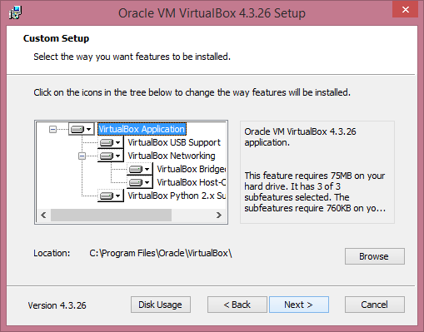

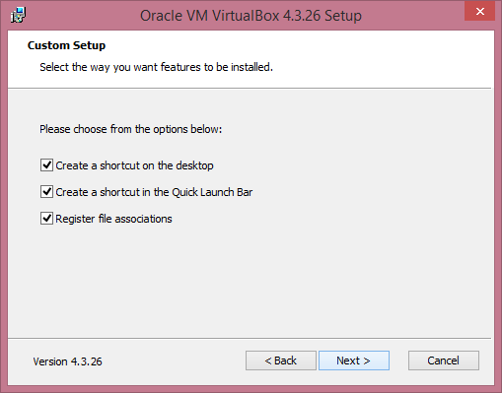

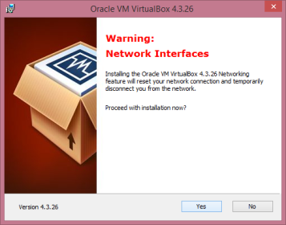

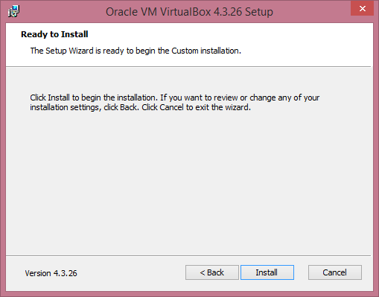

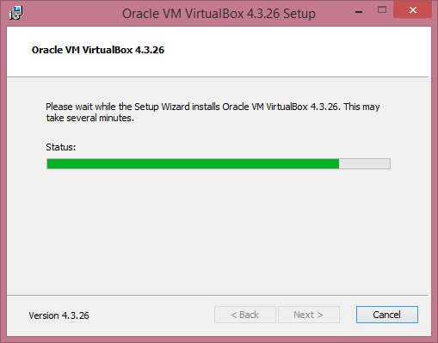

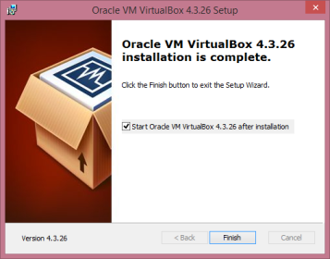

**Start Virtual box**

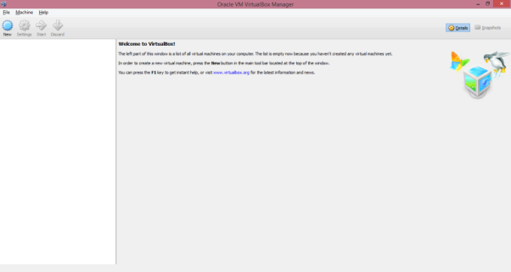

**Click New to Create node for DNS**

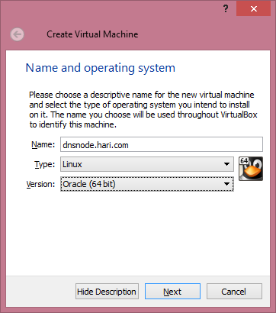

**Provide memory size (2GB is sufficient for DNS Server)**

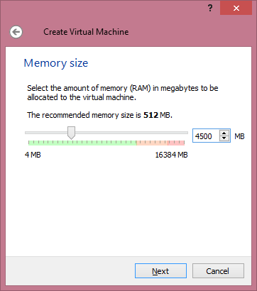s

**Create Virtual Hard Drive**

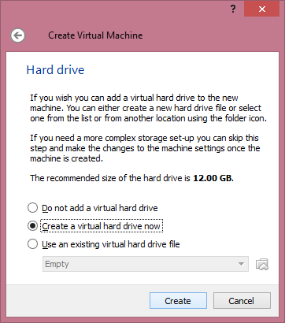

**Select VDI option**

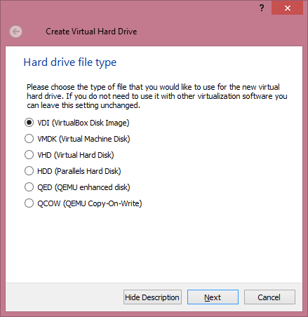

**Select Dynamically Allocated**

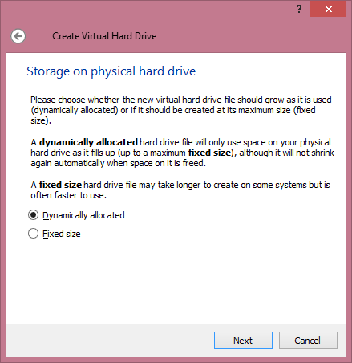

**Provide Size of Disk, Minimum of 8 GB is suffice**

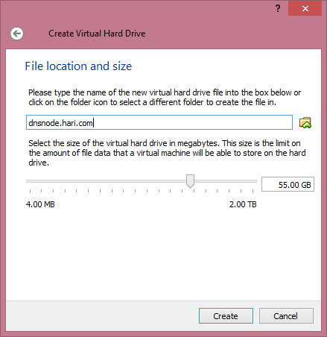

**Right Click on the Machine Settings, Remove floppy**

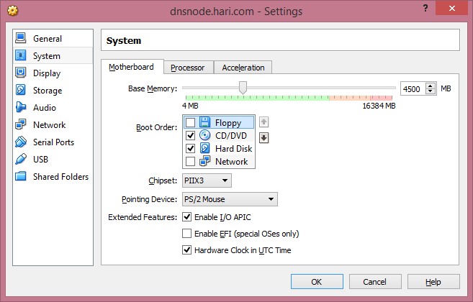

**Configure Network to use Bridged Adapter**

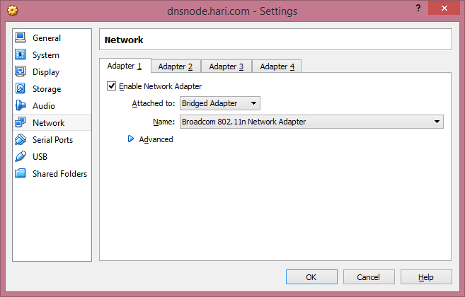

**Click on Start to Start virtual machine**

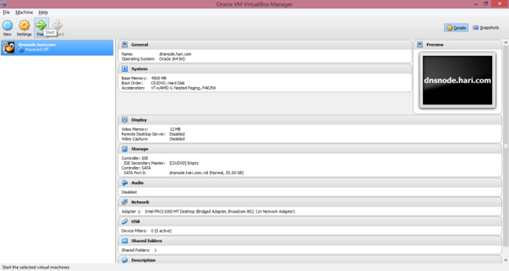

**Select Boot media or browse for Oracle Linux 7 Software**

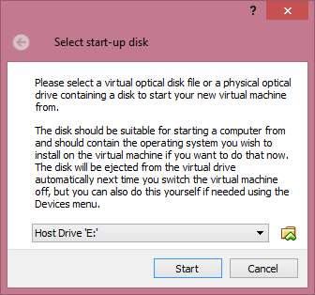

**Select ISO File**

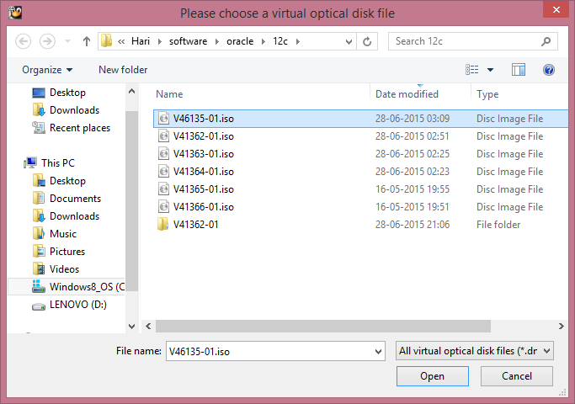

**Follow Steps for Node1 from Page 17 for installing Oracle Linux OS**

**Set host name**

[root@localhost ~]# hostnamectl set-hostname dnsnode.hari.com

[root@localhost ~]# hostnamectl status

Static hostname: dnsnode.hari.com

Icon name: computer

Chassis: n/a

Machine ID: b687b38ffd2c4758a2ec76a3297c6fe8

Boot ID: 6e7e2c7ee01f4c7ca19081a3818ecb2e

Virtualization: oracle

Operating System: Oracle Linux Server 7.0

CPE OS Name: cpe:/o:oracle:oracle_linux:7.0:GA:server

Kernel: Linux 3.8.13-35.3.1.el7uek.x86_64

Architecture: x86_64

**Install BIND rpm for DNS**

[root@dnsnode ~]# yum install bind -y

Loaded plugins: langpacks

ol7_UEKR3 | 1.2 kB 00:00:00

ol7_latest | 1.4 kB

.

.

.

Dependency Updated:

bind-libs.x86_64 32:9.9.4-18.el7_1.1 bind-libs-lite.x86_64 32:9.9.4-18.el7_1.1 bind-license.noarch 32:9.9.4-18.el7_1.1

Complete!

**Install Chroot**

[root@dnsnode ~]# yum install bind-chroot -y

Loaded plugins: langpacks

Resolving Dependencies

--> Running transaction check

---> Package bind-chroot.x86_64 32:9.9.4-18.el7_1.1 will be installed

.

.

.

Installed:

bind-chroot.x86_64 32:9.9.4-18.el7_1.1

Complete!

**Below is content of named.conf which you can modify according to your network settings**

[root@dnsnode named]# cat /etc/named.conf

options {

// Set IP address correctly.

listen-on port 53 { 127.0.0.1; 192.168.0.40; };

directory "/var/named"; // the default

dump-file "data/cache_dump.db";

statistics-file "data/named_stats.txt";

memstatistics-file "data/named_mem_stats.txt";

version "currently unavailable";

forwarders { 218.248.255.146; 218.248.255.139; };

};

zone "hari.com" in {

type master;

file "hari.com.ns";

allow-update { none; };

};

zone "0.168.192.in-addr.arpa" in {

type master;

file "0.168.192.in-addr.arpa.ns";

allow-update { none; };

};

**Below is content of DNS forward lookup zone which you can modify according to your network settings**

[root@dnsnode named]# cat /var/named/hari.com.ns

$TTL 1d

hari.com. IN SOA dnsnode.hari.com. support.hari.com. (

2010031500 ; se = serial number

3h ; ref = refresh

15m ; ret = update retry

3w ; ex = expiry

3h ; min = minimum

)

IN NS dnsnode.hari.com.

; private hosts

dnsnode IN A 192.168.0.40

node1 IN A 192.168.0.101

node2 IN A 192.168.0.102

node3 IN A 192.168.0.103

node4 IN A 192.168.0.104

node5 IN A 192.168.0.105

node6 IN A 192.168.0.106

node1-vip IN A 192.168.0.201

node2-vip IN A 192.168.0.202

node3-vip IN A 192.168.0.203

node4-vip IN A 192.168.0.204

node5-vip IN A 192.168.0.205

node6-vip IN A 192.168.0.206

node1-priv IN A 192.168.1.101

node2-priv IN A 192.168.1.102

node3-priv IN A 192.168.1.103

node4-priv IN A 192.168.1.104

node5-priv IN A 192.168.1.105

node6-priv IN A 192.168.1.106

racdb-scan IN A 192.168.0.71

racdb-scan IN A 192.168.0.72

racdb-scan IN A 192.168.0.73

**Below is content of DNS reverse lookup zone which you can modify according to your network settings**

[root@dnsnode named]# cat /var/named/0.168.192.in-addr.arpa.ns

$TTL 1d

@ IN SOA dnsnode.hari.com. support.hari.com. (

2010031500 ; se = serial number

3h ; ref = refresh

15m ; ret = update retry

3w ; ex = expiry

3h ; min = minimum

)

IN NS dnsnode.hari.com.

; private hosts, reverse lookup

40 IN PTR dnsnode.hari.com.

101 IN PTR node1.

102 IN PTR node2.

103 IN PTR node3.

104 IN PTR node4.

105 IN PTR node5.

106 IN PTR node6.

201 IN PTR node1-vip.

202 IN PTR node2-vip.

203 IN PTR node3-vip.

204 IN PTR node4-vip.

205 IN PTR node5-vip.

206 IN PTR node6-vip.

71 IN PTR racdb-scan.

72 IN PTR racdb-scan.

73 IN PTR racdb-scan.

**Add search and nameserver in resolv.conf to point to DNS**

[root@dnsnode named]# cat /etc/resolv.conf

# Generated by NetworkManager

search hari.com

nameserver 192.168.0.40

**Make named service to start automatically on reboot**

[root@dnsnode named]# chkconfig named on

Note: Forwarding request to 'systemctl enable named.service'.

ln -s '/usr/lib/systemd/system/named.service' '/etc/systemd/system/multi-user.target.wants/named.service'

**Verify Named service status**

[root@dnsnode named]# systemctl status named.service

named.service - Berkeley Internet Name Domain (DNS)

Loaded: loaded (/usr/lib/systemd/system/named.service; enabled)

Active: active (running) since Sun 2015-07-12 10:48:36 IST; 7min ago

Main PID: 3612 (named)

CGroup: /system.slice/named.service

└─3612 /usr/sbin/named -u named

Jul 12 10:48:36 dnsnode.hari.com named[3612]: automatic empty zone: B.E.F.IP6.ARPA

Jul 12 10:48:36 dnsnode.hari.com named[3612]: automatic empty zone: 8.B.D.0.1.0.0.2.IP6.ARPA

Jul 12 10:48:36 dnsnode.hari.com named[3612]: command channel listening on 127.0.0.1#953

Jul 12 10:48:36 dnsnode.hari.com named[3612]: command channel listening on ::1#953

Jul 12 10:48:36 dnsnode.hari.com named[3612]: managed-keys-zone: loaded serial 0

Jul 12 10:48:36 dnsnode.hari.com named[3612]: zone 0.168.192.in-addr.arpa/IN: loaded serial 2010031500

Jul 12 10:48:36 dnsnode.hari.com named[3612]: zone hari.com/IN: loaded serial 2010031500

Jul 12 10:48:36 dnsnode.hari.com named[3612]: all zones loaded

Jul 12 10:48:36 dnsnode.hari.com named[3612]: running

Jul 12 10:48:36 dnsnode.hari.com systemd[1]: Started Berkeley Internet Name Domain (DNS).

**Verify DNS lookup is successful**

[root@dnsnode named]# nslookup dnsnode

Server: 192.168.0.40

Address: 192.168.0.40#53

Name: dnsnode.hari.com

Address: 192.168.0.40

[root@dnsnode named]# nslookup node1

Server: 192.168.0.40

Address: 192.168.0.40#53

Name: node1.hari.com

Address: 192.168.0.101

**Click new on Virtual box to configure node1**

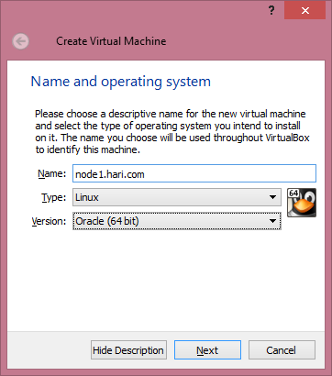







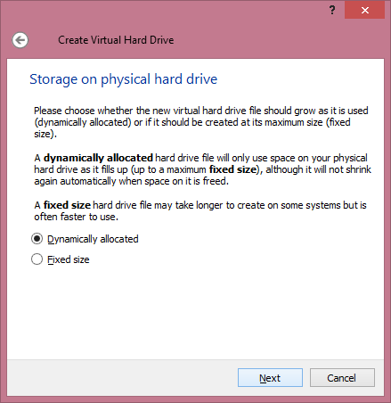

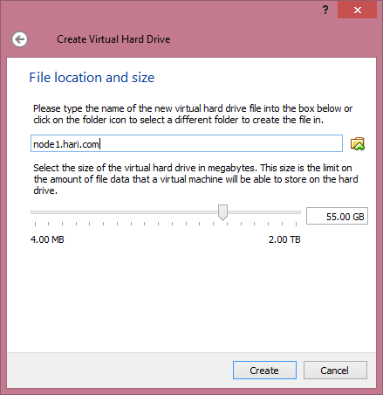

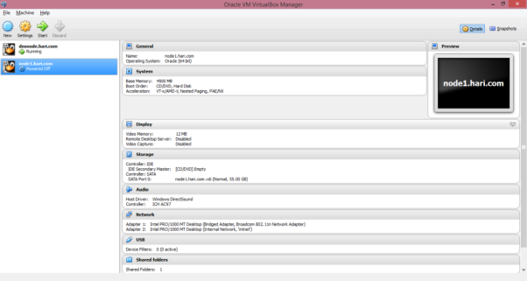



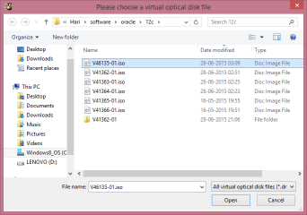

**Press any key to skip media test**

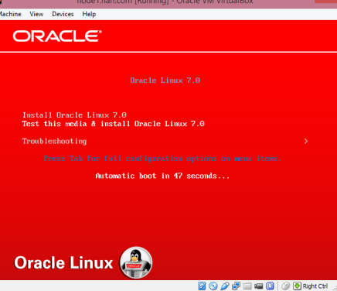

**Select Language**

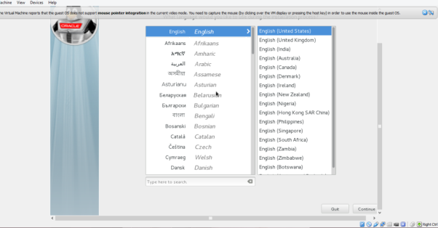

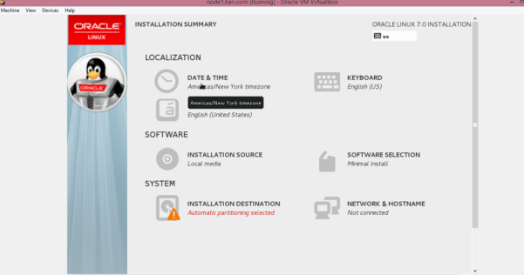

**Set timezone**

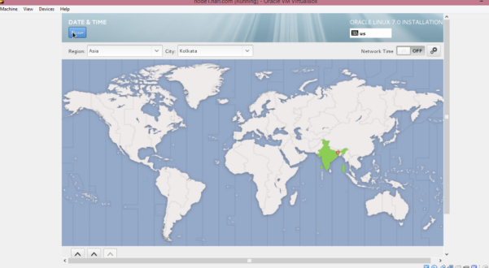

**Select Server with GUI and additionally choose Hardware Monitoring Tools, Performance Tools**

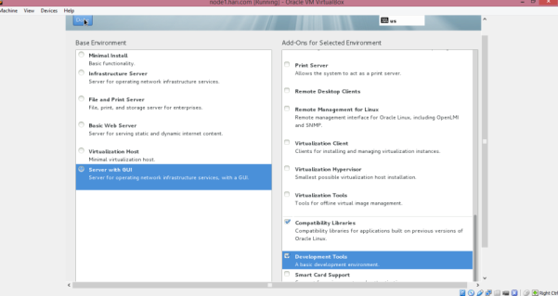

**Create mountpoint**

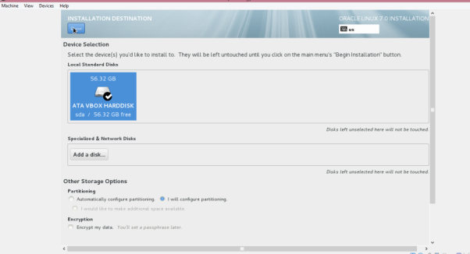

**Add root mountpoint (minimum 25 GB)**

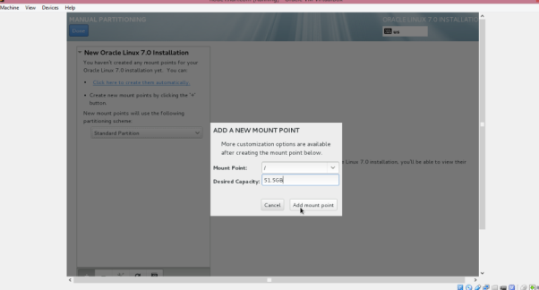

**Choose ext4 filesystem**

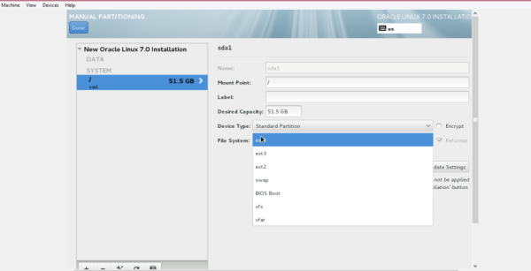

**Add SWAP (Since memory is 4.5 GB, have to be of same size or more)**

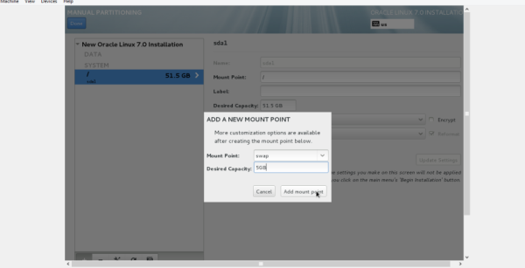

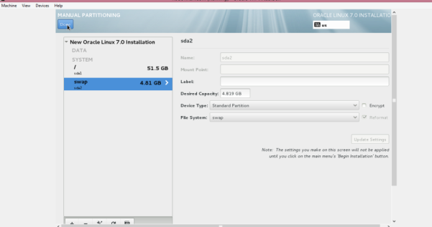

**Accept changes**

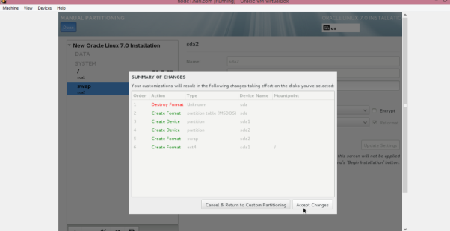

**Configure network and hostname**

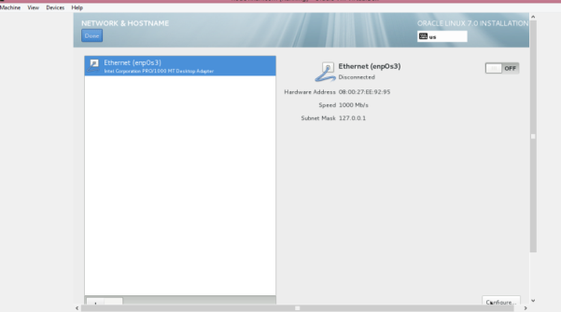

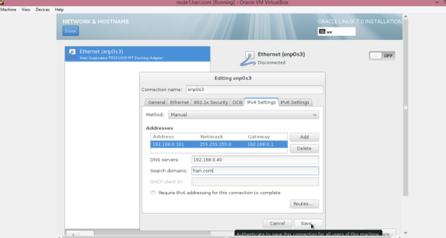

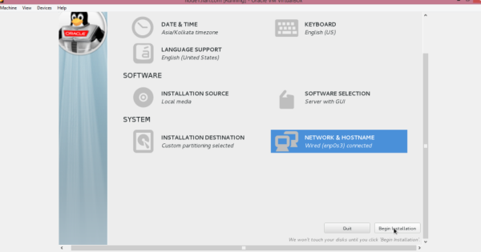

**Create user and set root password**

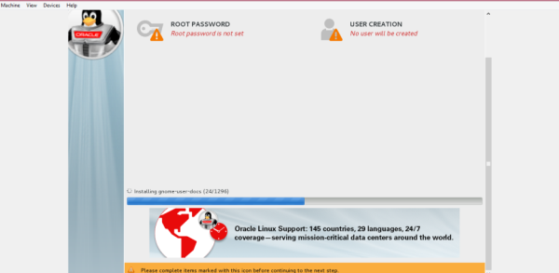

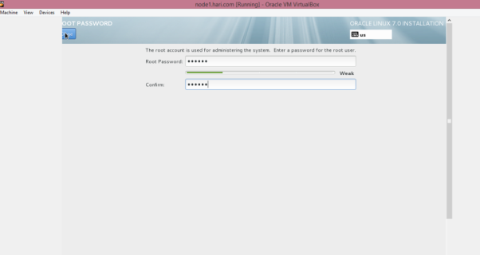

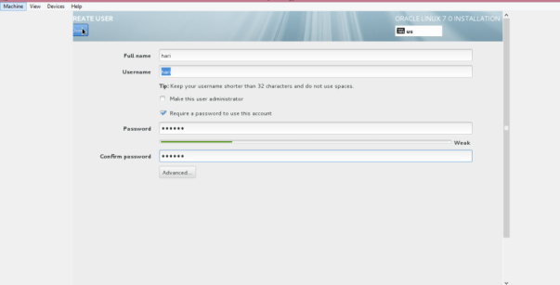

**Start Install**

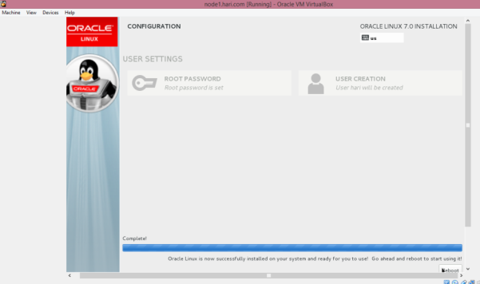

**On restart Disable kdump**

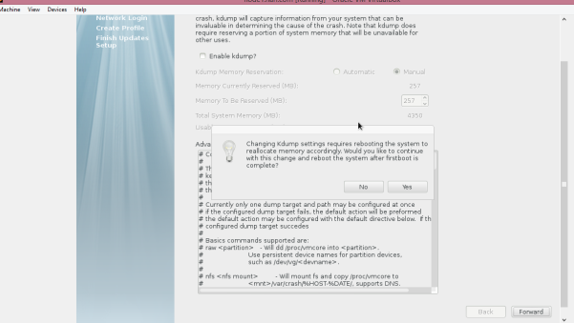

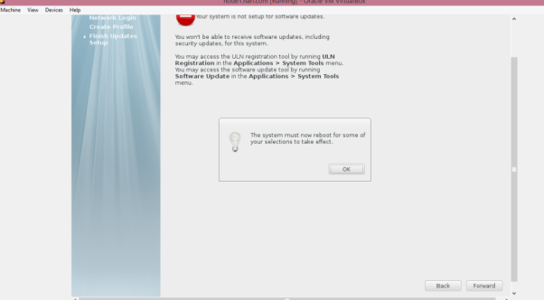

**Install Guest Additions for guest OS**

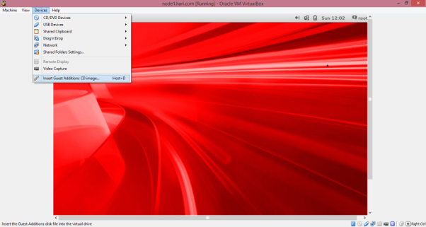

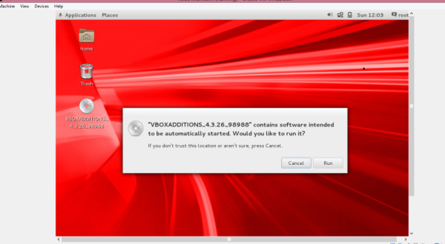

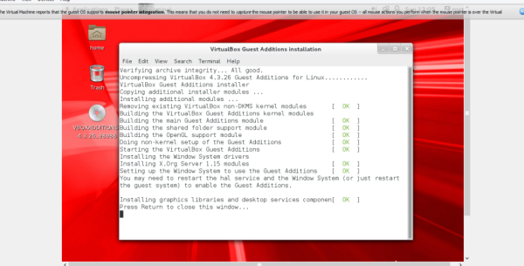

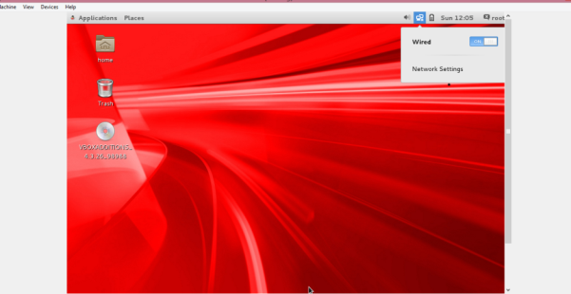

**Verify/Configure additional Adapter for private interconnect**

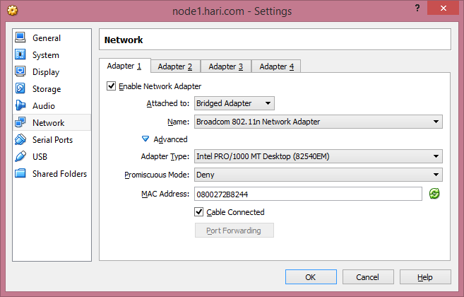

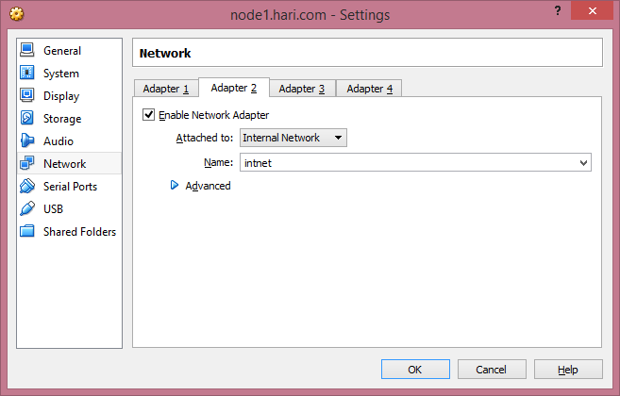

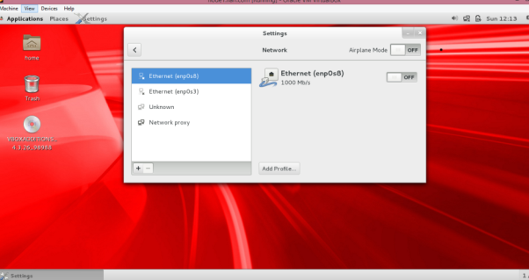

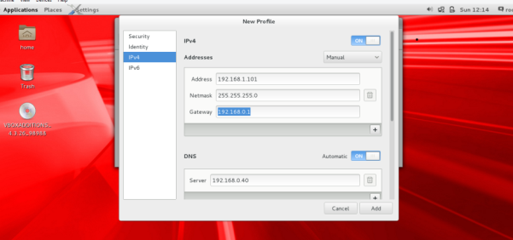

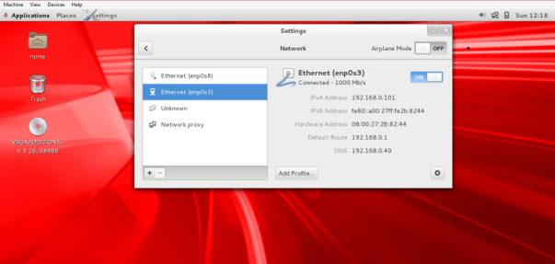

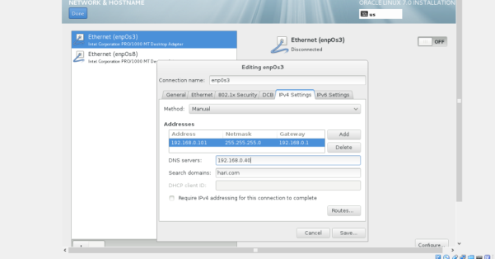

**Verify using Ifconfig**

[root@localhost ~]# ifconfig -a

enp0s3: flags=4163<UP,BROADCAST,RUNNING,MULTICAST> mtu 1500

inet 192.168.0.101 netmask 255.255.255.0 broadcast 192.168.0.255

inet6 fe80::a00:27ff:fe8a:6c4c prefixlen 64 scopeid 0x20<link>

ether 08:00:27:8a:6c:4c txqueuelen 1000 (Ethernet)

RX packets 175 bytes 18917 (18.4 KiB)

RX errors 0 dropped 0 overruns 0 frame 0

TX packets 167 bytes 21913 (21.3 KiB)

TX errors 0 dropped 0 overruns 0 carrier 0 collisions 0

enp0s8: flags=4163<UP,BROADCAST,RUNNING,MULTICAST> mtu 1500

inet 192.168.1.101 netmask 255.255.255.0 broadcast 192.168.1.255

inet6 fe80::a00:27ff:fe1d:f3ca prefixlen 64 scopeid 0x20<link>

ether 08:00:27:1d:f3:ca txqueuelen 1000 (Ethernet)

RX packets 0 bytes 0 (0.0 B)

RX errors 0 dropped 0 overruns 0 frame 0

TX packets 9 bytes 698 (698.0 B)

TX errors 0 dropped 0 overruns 0 carrier 0 collisions 0

lo: flags=73<UP,LOOPBACK,RUNNING> mtu 65536

inet 127.0.0.1 netmask 255.0.0.0

inet6 ::1 prefixlen 128 scopeid 0x10<host>

loop txqueuelen 0 (Local Loopback)

RX packets 13 bytes 1360 (1.3 KiB)

RX errors 0 dropped 0 overruns 0 frame 0

TX packets 13 bytes 1360 (1.3 KiB)

TX errors 0 dropped 0 overruns 0 carrier 0 collisions 0

**Set hostname**

[root@localhost ~]# hostnamectl set-hostname node1.hari.com

[root@localhost ~]# hostname

node1.hari.com

**Disable iptables and firewall**

[root@node1 ~]# systemctl stop iptables.service

[root@node1 ~]# systemctl status iptables.service

iptables.service - IPv4 firewall with iptables

Loaded: loaded (/usr/lib/systemd/system/iptables.service; disabled)

Active: inactive (dead)

Jul 18 20:29:37 node1.hari.com systemd[1]: Stopped IPv4 firewall with iptables.

Jul 18 20:29:55 node1.hari.com systemd[1]: Stopped IPv4 firewall with iptables.

[root@node1 ~]# systemctl status firewalld.service

firewalld.service - firewalld - dynamic firewall daemon

Loaded: loaded (/usr/lib/systemd/system/firewalld.service; enabled)

Active: active (running) since Sat 2015-07-18 20:37:05 IST; 8min ago

Main PID: 452 (firewalld)

CGroup: /system.slice/firewalld.service

└─452 /usr/bin/python -Es /usr/sbin/firewalld --nofork --nopid

Jul 18 20:37:05 node1.hari.com systemd[1]: Started firewalld - dynamic firewall daemon.

[root@node1 ~]# systemctl stop firewalld.service

[root@node1 ~]# systemctl disable firewalld.service

rm '/etc/systemd/system/dbus-org.fedoraproject.FirewallD1.service'

rm '/etc/systemd/system/basic.target.wants/firewalld.service'

**Disable Selinux**

[root@node1 selinux]# cat config

# This file controls the state of SELinux on the system.

# SELINUX= can take one of these three values:

# enforcing - SELinux security policy is enforced.

# permissive - SELinux prints warnings instead of enforcing.

# disabled - No SELinux policy is loaded.

SELINUX=disabled

# SELINUXTYPE= can take one of these two values:

# targeted - Targeted processes are protected,

# minimum - Modification of targeted policy. Only selected processes are protected.

# mls - Multi Level Security protection.

#SELINUXTYPE=targeted

After reboot you should see selinux disabled

[root@node1 ~]# sestatus

SELinux status: disabled

**Install below RPM**

binutils

compat-libcap1

compat-libstdc++-33

gcc

gcc-c++

glibc

glibc-devel

ksh

libgcc

libstdc++

libstdc++-devel

libaio

libaio-devel

libXext

libXtst

libX11

libXau

libxcb

libXi

make

sysstat

libXmu

libXt

libXv

libXxf86dgak

libXxf86misc

libXxf86vm

xorg-x11-utils

xorg-x11-xauth

nfs-utils

**Add #Oracle Settings to sysctl.conf**

[root@node1 ~]# cat /etc/sysctl.conf

# System default settings live in /usr/lib/sysctl.d/00-system.conf.

# To override those settings, enter new settings here, or in an /etc/sysctl.d/<name>.conf file

#

# For more information, see sysctl.conf(5) and sysctl.d(5).

#Oracle Settings

#Setting Virtual Memory

vm.swappiness = 1

vm.dirty_background_ratio = 3

vm.dirty_ratio = 80

vm.dirty_expire_centisecs = 500

vm.dirty_writeback_centisecs = 100

#Setting Shared Memory

kernel.shmmax = 4398046511104

kernel.shmall = 1073741824

kernel.shmmni = 4096

#Setting Semaphores

kernel.sem = 250 32000 100 128

#Network Ports

net.ipv4.ip_local_port_range = 9000 65500

#Network Settings

net.core.rmem_default = 262144

net.core.rmem_max = 4194304

net.core.wmem_default = 262144

net.core.wmem_max = 1048576

#synchronous I/O Requests

fs.aio-max-nr = 1048576

#File Handles

fs.file-max = 6815744

#Kernel Panic On OOPS Parameter

kernel.panic_on_oops = 1

#Reverse Path Filtering

net.ipv4.conf.enp0s8.rp_filter = 2

net.ipv4.conf.enp0s3.rp_filter = 2

**Make changes to sysctl permanent**

[root@node1 ~]# sysctl -p /etc/sysctl.conf

vm.swappiness = 1

vm.dirty_background_ratio = 3

vm.dirty_ratio = 80

vm.dirty_expire_centisecs = 500

vm.dirty_writeback_centisecs = 100

kernel.shmmax = 4398046511104

kernel.shmall = 1073741824

kernel.shmmni = 4096

kernel.sem = 250 32000 100 128

net.ipv4.ip_local_port_range = 9000 65500

net.core.rmem_default = 262144

net.core.rmem_max = 4194304

net.core.wmem_default = 262144

net.core.wmem_max = 1048576

fs.aio-max-nr = 1048576

fs.file-max = 6815744

kernel.panic_on_oops = 1

net.ipv4.conf.enp0s8.rp_filter = 2

net.ipv4.conf.enp0s3.rp_filter = 2

**Also add to /etc/sysctl.d/98-oracle.conf**

**Add Oracle groups and Users**

[root@node1 ~]# groupadd --gid 54321 oinstall

[root@node1 ~]# groupadd --gid 54322 dba

[root@node1 ~]# groupadd --gid 54323 asmdba

[root@node1 ~]# groupadd --gid 54324 asmoper

[root@node1 ~]# groupadd --gid 54325 asmadmin

[root@node1 ~]# groupadd --gid 54326 oper

[root@node1 ~]# groupadd --gid 54327 backupdba

[root@node1 ~]# groupadd --gid 54328 dgdba

[root@node1 ~]# groupadd --gid 54329 kmdba

[root@node1 ~]# useradd --uid 54321 --gid oinstall --groups dba,oper,asmdba,asmoper,backupdba,dgdba,kmdba oracle

[root@node1 ~]# useradd --uid 54322 --gid oinstall --groups dba,asmadmin,asmdba,asmoper grid

[root@node1 ~]# passwd oracle

Changing password for user oracle.

New password:

BAD PASSWORD: The password is shorter than 8 characters

Retype new password:

passwd: all authentication tokens updated successfully.

[root@node1 ~]# passwd grid

Changing password for user grid.

New password:

BAD PASSWORD: The password is shorter than 8 characters

Retype new password:

passwd: all authentication tokens updated successfully.

**Add below limits.d**

[root@node1 profile.d]# cat /etc/security/limits.d/99-grid-oracle-limits.conf

#Oracle Settings

oracle soft nproc 16384

oracle hard nproc 16384

oracle soft nofile 1024

oracle hard nofile 65536

oracle soft stack 10240

oracle hard stack 32768

grid soft nproc 16384

grid hard nproc 16384

grid soft nofile 1024

grid hard nofile 65536

grid soft stack 10240

grid hard stack 32768

[root@node1 profile.d]#

**Set NOZEROCONF to Yes**

[root@node1 profile.d]# cat /etc/sysconfig/network

# Created by anacondaa

NOZEROCONF=yes

**Set tmpfs filesystem same as memory or less**

[root@node1 profile.d]# cat /etc/fstab

#

# /etc/fstab

# Created by anaconda on Sun Jul 12 09:16:30 2015

#

# Accessible filesystems, by reference, are maintained under '/dev/disk'

# See man pages fstab(5), findfs(8), mount(8) and/or blkid(8) for more info

#

UUID=e314124e-35f7-4730-9fc5-0d68ec35f74e / ext4 defaults 1 1

UUID=1f75633d-894c-4c12-affc-0f19b843c1d0 swap swap defaults 0 0

tmpfs /dev/shm tmpfs size=4.2g 0 0

**Add bash profile to grid and oracle user**

[root@node1 ~]# cat /home/oracle/.bash_profile

# .bash_profile

# ---------------------------------------------------

# OS User: oracle

# Application: Oracle Database Software Owner

# Version: Oracle 12.1.0.2

# ---------------------------------------------------

# Get the aliases and functions

if [ -f ~/.bashrc ]; then

. ~/.bashrc

fi

ORACLE_SID=racdb1; export ORACLE_SID

ORACLE_UNQNAME=racdb; export ORACLE_UNQNAME

JAVA_HOME=/usr/local/java; export JAVA_HOME

ORACLE_BASE=/u01/app/oracle; export ORACLE_BASE

ORACLE_HOME=$ORACLE_BASE/product/12.1.0/dbhome_1; export ORACLE_HOME

ORACLE_PATH=/u01/app/common/oracle/sql; export ORACLE_PATH

ORACLE_TERM=xterm; export ORACLE_TERM

NLS_DATE_FORMAT="DD-MON-YYYY HH24:MI:SS"; export NLS_DATE_FORMAT

TNS_ADMIN=$ORACLE_HOME/network/admin; export TNS_ADMIN

ORA_NLS11=$ORACLE_HOME/nls/data; export ORA_NLS11

PATH=.:${JAVA_HOME}/bin:${PATH}:$HOME/bin:$ORACLE_HOME/bin

PATH=${PATH}:/usr/bin:/bin:/usr/bin/X11:/usr/local/bin

PATH=${PATH}:/u01/app/common/oracle/bin

export PATH

LD_LIBRARY_PATH=$ORACLE_HOME/lib

LD_LIBRARY_PATH=${LD_LIBRARY_PATH}:$ORACLE_HOME/oracm/lib

LD_LIBRARY_PATH=${LD_LIBRARY_PATH}:/lib:/usr/lib:/usr/local/lib

export LD_LIBRARY_PATH

CLASSPATH=$ORACLE_HOME/JRE

CLASSPATH=${CLASSPATH}:$ORACLE_HOME/jlib

CLASSPATH=${CLASSPATH}:$ORACLE_HOME/rdbms/jlib

CLASSPATH=${CLASSPATH}:$ORACLE_HOME/network/jlib

export CLASSPATH

THREADS_FLAG=native; export THREADS_FLAG

export TEMP=/tmp

export TMPDIR=/tmp

umask 022

[root@node1 ~]# cat /home/grid/.bash_profile

# .bash_profile

# ---------------------------------------------------

# OS User: grid

# Application: Oracle Grid Infrastructure

# Version: Oracle 12.1.0.2

# ---------------------------------------------------

# Get the aliases and functions

if [ -f ~/.bashrc ]; then

. ~/.bashrc

fi

ORACLE_SID=+ASM1; export ORACLE_SID

JAVA_HOME=/usr/local/java; export JAVA_HOME

ORACLE_BASE=/u01/app/grid; export ORACLE_BASE

ORACLE_HOME=/u01/app/12.1.0/grid; export ORACLE_HOME

ORACLE_PATH=/u01/app/oracle/common/oracle/sql; export ORACLE_PATH

ORACLE_TERM=xterm; export ORACLE_TERM

NLS_DATE_FORMAT="DD-MON-YYYY HH24:MI:SS"; export NLS_DATE_FORMAT

TNS_ADMIN=$ORACLE_HOME/network/admin; export TNS_ADMIN

ORA_NLS11=$ORACLE_HOME/nls/data; export ORA_NLS11

PATH=.:${JAVA_HOME}/bin:${PATH}:$HOME/bin:$ORACLE_HOME/bin

PATH=${PATH}:/usr/bin:/bin:/usr/bin/X11:/usr/local/bin

PATH=${PATH}:/u01/app/common/oracle/bin

export PATH

LD_LIBRARY_PATH=$ORACLE_HOME/lib

LD_LIBRARY_PATH=${LD_LIBRARY_PATH}:$ORACLE_HOME/oracm/lib

LD_LIBRARY_PATH=${LD_LIBRARY_PATH}:/lib:/usr/lib:/usr/local/lib

export LD_LIBRARY_PATH

CLASSPATH=$ORACLE_HOME/JRE

CLASSPATH=${CLASSPATH}:$ORACLE_HOME/jlib

CLASSPATH=${CLASSPATH}:$ORACLE_HOME/rdbms/jlib

CLASSPATH=${CLASSPATH}:$ORACLE_HOME/network/jlib

export CLASSPATH

THREADS_FLAG=native; export THREADS_FLAG

export TEMP=/tmp

export TMPDIR=/tmp

umask 022

**Create node2 from clone of node1**

